Weekly Construction Progress Report – Week 37
Harrow Bay Offshore Wind · 07 Sep – 13 Sep 2026
Elena Márquez · 14 September 2026 · HB-PM-RPT-2026-W37

1. Summary
1 monopile (HB-A13) was installed this week, bringing the total to 13 of 40. The foundation campaign is 3 piles behind the Rev 2 baseline (16 planned). Waiting on weather amounted to 33 hours.
Area | Status | Comment
Overall schedule | Red | 13/40 monopiles vs. 16 planned
Foundations | Red | TPs installed: 12
Offshore substation | Green | Topside installed 19 Aug
Cables | Red | Export cable 2 delay – HB-RISK-017
HSE | Green | No incidents

2. Progress
Metric | This week | Cumulative | Plan (cum.) | Variance
Monopiles installed | 1 | 13 | 16 | -3
Transition pieces installed | 0 | 12 | – | –
Waiting on weather (h) | 33 | 423 | – | –
Persons on board (avg.) | 94 | – | – | –
Man-hours MV Sea Atlas | 7,844 | 187,120 | – | –
Lost time injuries | 0 | 0 | 0 | 0
Recordable injuries | 0 | 1 | – | –
Near misses reported | 0 | 4 | – | –
HSE observation cards | 17 | – | – | –

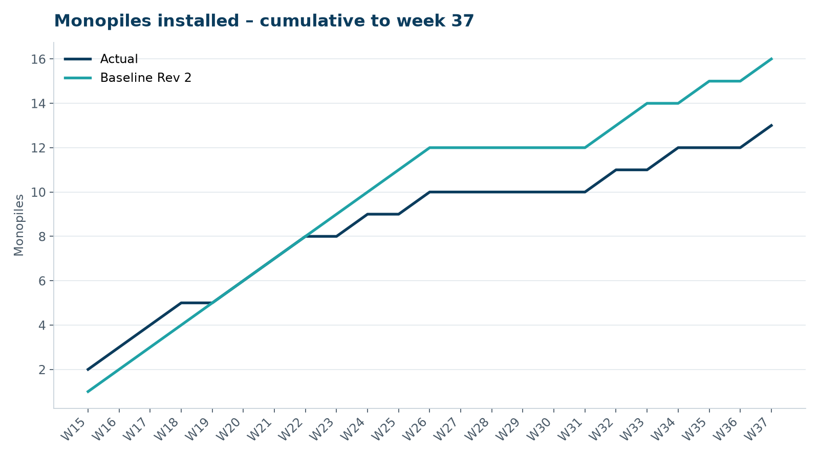
Figure 1 – Monopile installation progress, W15 to W37

3. Key activities this week
- HB-A13 installed on 11 September; transition piece installed on 14 September.
- Revised cable lay sequence (export cable 1 first, array strings A and B earlier) issued for review.
- 33 hours waiting on weather.

4. Health and safety
No lost time injuries. 17 observation cards submitted; top theme: mooring line handling.

5. Environment
- HB-A13: peak 158.7 dB SEL at 750 m (compliant); harbour porpoise detected in the mitigation zone during the pre-piling search, soft start delayed by 12 min.

6. Issues and risks
- HB-RISK-017 export cable 2 delay – recovery programme received; resequencing of cable lay campaign in progress.
- HB-RISK-001 weather: 33 h downtime this week.
- HB-RISK-029 monopile campaign into winter – recovery plan in preparation.

7. Look-ahead next week
Install HB-A14 and HB-B01.
Prepared by Project Controls (Gareth Lewis); approved by Elena Márquez. Distribution: project team, Steering Committee, Halden Turbine Systems, Lenders' Technical Adviser.

